E.E.T.P. N° 485 “VicecomodoroMarambio”CURSO: 1°Año
Lengua extranjera “Inglés”
TRABAJO PRÁCTICO INTEGRADOR 2020
How are you? Espero que sigas muy bien. Aquí te presento el Trabajo Práctico integrador con los contenidos vistos en 2020, cualquier duda o inquietud, te podés comunicar por mail
DOCENTES:
101/107: CLAUDIO BLANCO Correo: claudiofenglish@hotmail.com
102/103: ROMINA FERREYRA Correo: rferreyra.ferreyra@gmail.com
104/105/106 DANIELA SOLA Correo:danielamarisasola1973@gmail.com

- Match questions and answers(Unir preguntas y respuestas)
What’syourname? | I’m fine, thanks.
How are youtoday? | It’s red.
Where are you from? | It’s 0341-15887643
Howold are you? | Myname’sJim.
What’syourfavouritecolour? | I’mfrom Australia.
What’s your mobile pone number? | I’m 13 yearsold.

- Completeusing HAS/ HASN’T/ HAVE/ HAVEN’T (Completar)
1- Mark …………………got a new toolbox.
2- I ………………………got a ruler. (x)
3- …………………….. Tina and Mike gotspanners?
4- What………………….yourfriendgot in hisschool bag?
5- Peter and Paul ………………..gottools.
6- ………………….yougot a new pair of scissors?
7- Gina ……………………got a bike. (x)

c) Choose the best option. (Elegir la mejor opción).

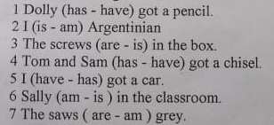

- Look at the picture and answer the questions(Observa la siguiente imagen y responde las preguntas)

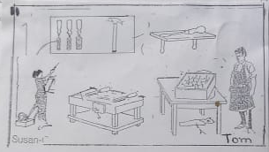

1- Where is the screwdriver?
2- Are the chisels on the bench?
3- Is the hammer on the table?
4- HasTom got an overall?
5- Are the files in the box?
6- Have they got a hammer?
7- Where are Tom and Susan?
8- Is the saw under the table?
9- What has Susan got in her hand?
10- Are Susan and Tom in the workshop?

